|  |  |
| --- | --- |
| NAME | Mohamed Abdullah M |
| TEAM ID | PNT2022TMID37442 |
| PROJECT TITLE | **IoT Based Safety Gadget for Child Safety Monitoring & Notification** |

**MILESTONE & ACTIVITY LIST**

How your child plays, learns, speaks, acts, and moves offers important clues about your child’s development. Developmental milestones are things most children (75% or more) can do by a certain age.

Check the milestones your child has reached by the end of 1 year by completing a checklist with CDC’s free [*Milestone Tracker*](http://www.cdc.gov/MilestoneTracker) mobile app, for [iOS](https://itunes.apple.com/us/app/cdcs-milestone-tracker/id1232718688?mt=8) and [Android](https://play.google.com/store/apps/details?id=gov.cdc.ncbddd.actearly.milestones) devices, [using the Digital Online Checklist](https://www.cdc.gov/ncbddd/actearly/milestones/digital-online-checklist.html)

**What most children do by this age:**

Social/Emotional Milestones

* Plays games with you, like pat-a-cake

Language/Communication Milestones

* Waves “bye-bye”
* Calls a parent “mama” or “dada” or another special name
* Understands “no” (pauses briefly or stops when you say it)

Cognitive Milestones (learning, thinking, problem-solving)

* Puts something in a container, like a block in a cup
* Looks for things he sees you hide, like a toy under a blanket

Movement/Physical Development Milestones

* Pulls up to stand
* Walks, holding on to furniture
* Drinks from a cup without a lid, as you hold it
* Picks things up between thumb and pointer finger, like small bits of food

Other important things to share with the doctor…

* What are some things you and your baby do together?
* What are some things your baby likes to do?
* Is there anything your baby does or does not do that concerns you?
* Has your baby lost any skills he/she once had?
* Does your baby have any special healthcare needs or was he/she born prematurely?

Download CDC’s free Milestone Tracker App

[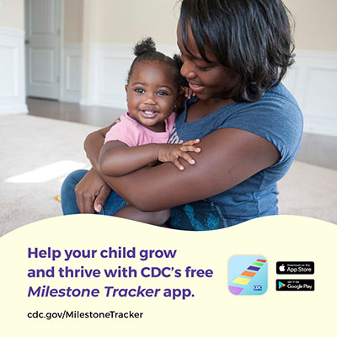](https://www.cdc.gov/ncbddd/actearly/milestones-app.html)

[View](https://www.cdc.gov/ncbddd/actearly/milestones-app.html)

Concerned About Your Child’s Development?  
Act Early.

**You know your child best.**Don’t wait. If your child is not meeting one or more milestones, has lost skills he or she once had, or you have other concerns, act early. Talk with your child’s doctor, share your concerns, and ask about developmental screening.

**If you or the doctor are still concerned:**

1. Ask for a referral to a specialist who can evaluate your child more; and
2. Call your state or territory’s early intervention program to find out if your child can get services to help. Learn more and find the number at [cdc.gov/FindEI](https://www.cdc.gov/FindEI).

For more on how to help your child, visit [cdc.gov/Concerned](https://www.cdc.gov/Concerned).

Tips and Activities: What You Can Do for Your 12 month old

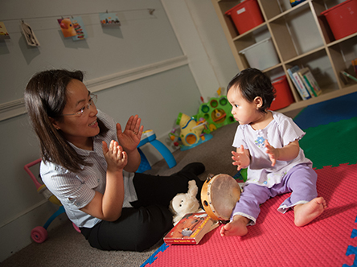

As your baby’s first teacher, you can help his or her learning and brain development. Try these simple tips and activities in a safe way. Talk with your baby’s doctor and teachers if you have questions or for more ideas on how to help your baby’s development.

* Teach your baby “wanted behaviors.” Show her what to do and use positive words or give her hugs and kisses when she does it. For example, if she pulls your pet’s tail, teach her how to pet gently and give her a hug when she does it.
* Talk or sing to your baby about what you’re doing. For example, “Mommy is washing your hands” or sing, “This is the way we wash our hands.”
* Build on what your baby tries to say. If he says “ta,” say “Yes, a truck,” or if he says “truck,” say “Yes, that’s a big, blue truck.”